Welcome To
Trinity Lutheran Church
Lutheran Church—Missouri Synod
A Stephen Ministry Congregation

1354 South Otsego Avenue
Gaylord, Michigan 49735
Church Phone: (989) 732-4816

Church Email: secretary@trinitygaylord.com
www.trinitygaylord.com

Office Hours: Monday through Friday 9am – 1pm

OUR PURPOSE
…is to LOVE GOD, LOVE OTHERS, AND SERVE THE WORLD by worshiping the Lord Jesus, bringing our members into Christ-like maturity, and equipping them through Word and Sacrament for their mission and ministry. We go heart to heart into the world with Jesus, sharing His love, caring for one another, praying, and bringing the lost into a relationship with Christ, by the working of the Holy Spirit.

August 21, 2022
Eleventh Sunday after Pentecost
Preacher: Rev. Paul Schneider

ABOUT OUR WORSHIP
We welcome all who gather here today! We are blessed to celebrate together the mercy, grace, and love we have from God through the death and resurrection of our Lord Jesus Christ.

Children: Families with children are very welcome here. Having children in church is important so they can begin to learn about their faith in Jesus, and it’s good for the whole congregation to see. Please feel comfortable keeping “squirmy” kids in the service. This is where they belong, too!

Pew Cards: Guests and Members, please fill out the Guest/Member card located on the back of the pew in front of you and pass it to the end of the aisle. If you forget you can put it in the offering plate on your way out.

If standing is difficult: Please feel free to remain seated during any portion of the service. Please let an Elder or Usher know if you need communion in your pew seat.

About our celebration of Holy Communion: We celebrate the Lord’s Supper in the confession and glad confidence that, as he says, our Lord gives into our mouths not only bread and wine but his very body and blood to eat and to drink for the forgiveness of sins and to strengthen our union with him and with one another. Our Lord invites to his table those who trust his words, repent of all sin, and set aside any refusal to forgive and love as he forgives and loves us, that they may show forth his death until he comes.

Because those who eat and drink our Lord’s body and blood contrary to that which is stated above do so to their great harm, and also because Holy Communion is a confession of the faith which is confessed at this altar. Anyone who is not yet instructed, in doubt, or who hold a confession differing from that of the Lutheran Church—Missouri Synod, and yet desire to receive the sacrament, are asked first to speak with Pastor. Those not communing are still invited to come forward for a blessing from Pastor, and you may indicate this by crossing your arms over your chest.
TTTTTT

GREETING

P Peace be with you.
C And also with you.
P Let us pray.
T ORDER OF SERVICE T
(The liturgy is from Divine Service Setting four LSB pg. 203ff)

OPENING HYMN
Rejoice, O Pilgrim Throng LSB 813 sts. 1, ref, 2–3
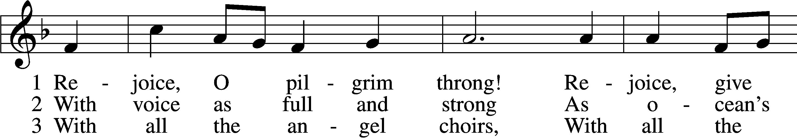
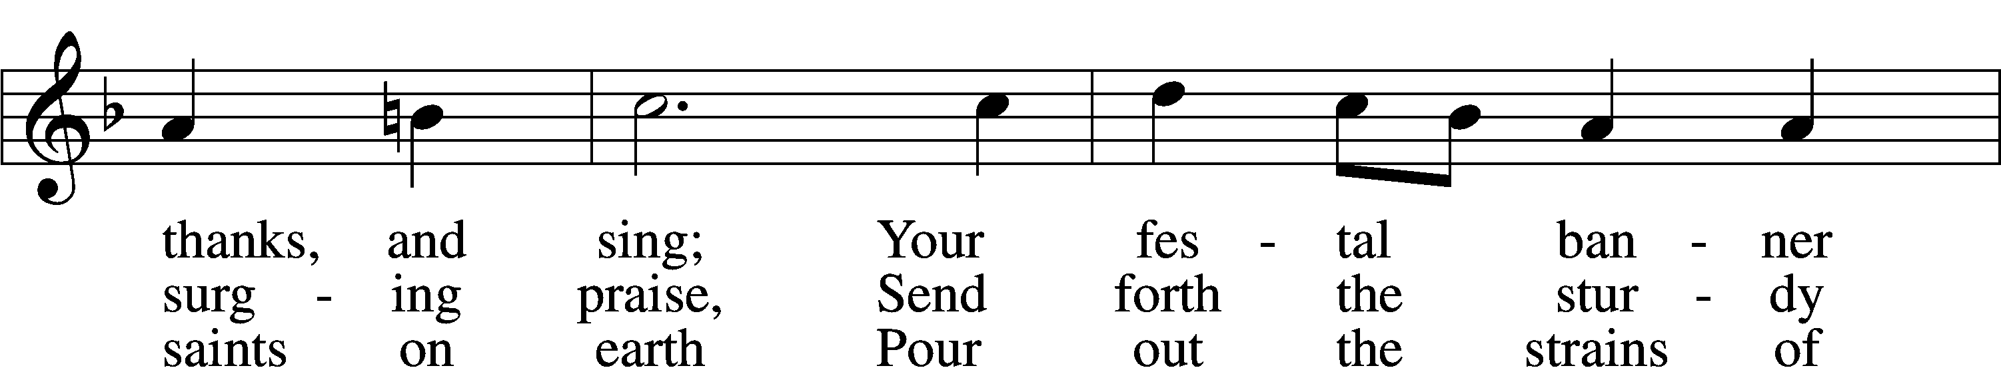
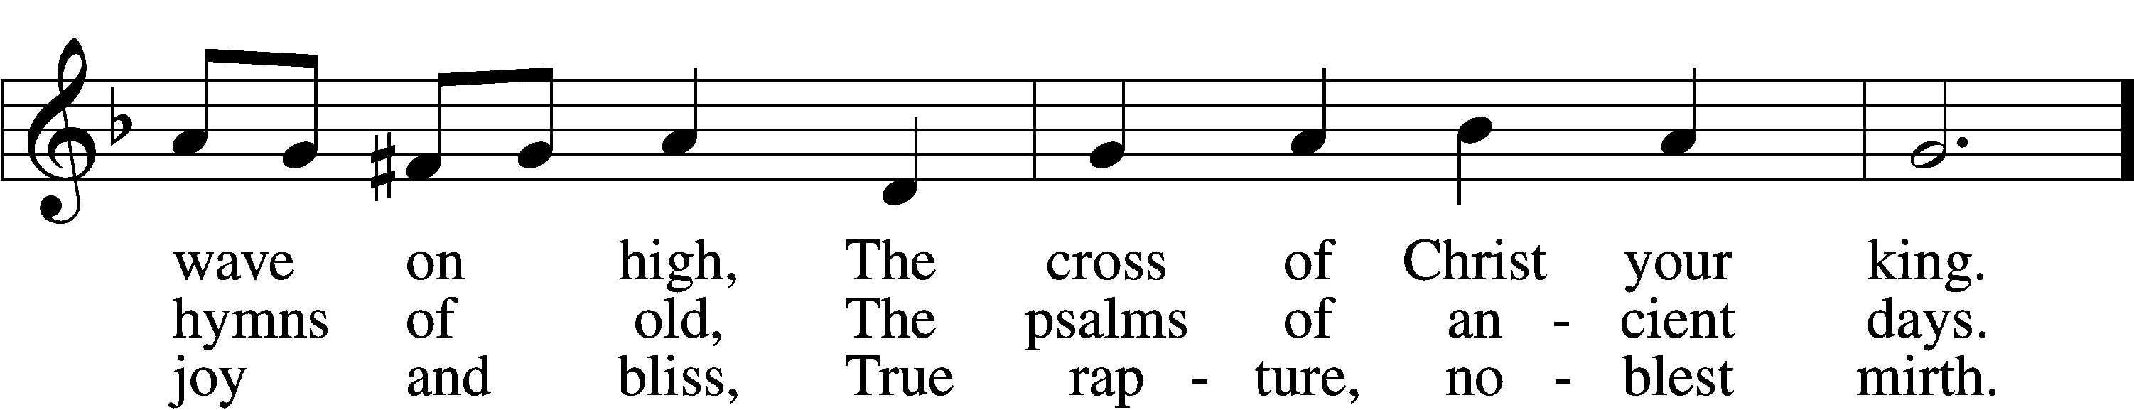
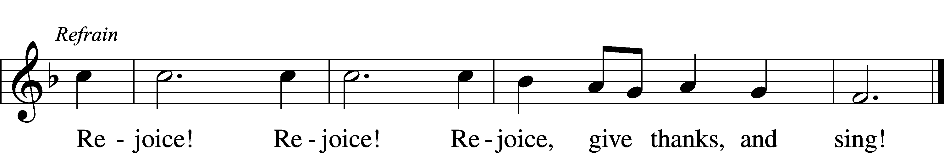
Text: Edward H. Plumptre, 1821–91, alt.
Tune: Arthur H. Messiter, 1834–1916
Text and tune: Public domain
Please stand as able
CONFESSION and ABSOLUTION
The sign of the cross may be made by all in remembrance of their Baptism.

P In the name of the Father and of the T Son and of the Holy Spirit.
C Amen.
P Our help is in the name of the Lord,
C who made heaven and earth.
P If You, O Lord, kept a record of sins, O Lord, who could stand?
C But with You there is forgiveness; therefore, You are feared.
P Since we are gathered to hear God’s Word, call upon Him in prayer and praise, and receive the body and blood of our Lord Jesus Christ in the fellowship of this altar, let us first consider our unworthiness and confess before God and one another that we have sinned in thought, word, and deed, and that we cannot free ourselves from our sinful condition. Together as His people let us take refuge in the infinite mercy of God, our heavenly Father, seeking His grace for the sake of Christ, and saying: God, be merciful to me, a sinner.
C Almighty God, have mercy upon us, forgive us our sins, and lead us to everlasting life. Amen.
P Almighty God in His mercy has given His Son to die for you and for His sake forgives you all your sins. As a called and ordained servant of Christ, and by His authority, I therefore forgive you all your sins in the name of the Father and of the T Son and of the Holy Spirit.
C Amen.

SERVICE OF THE WORD
KYRIE LSB 204
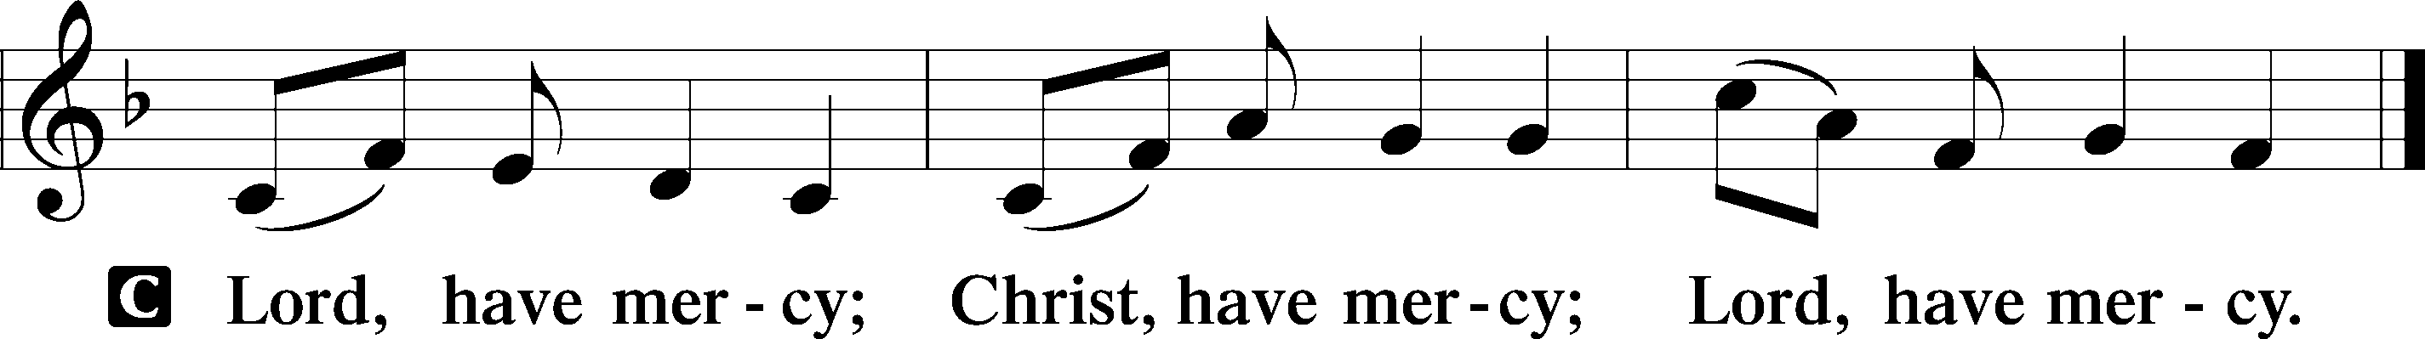

HYMN OF PRAISE
GLORIA IN EXCELSIS LSB 204
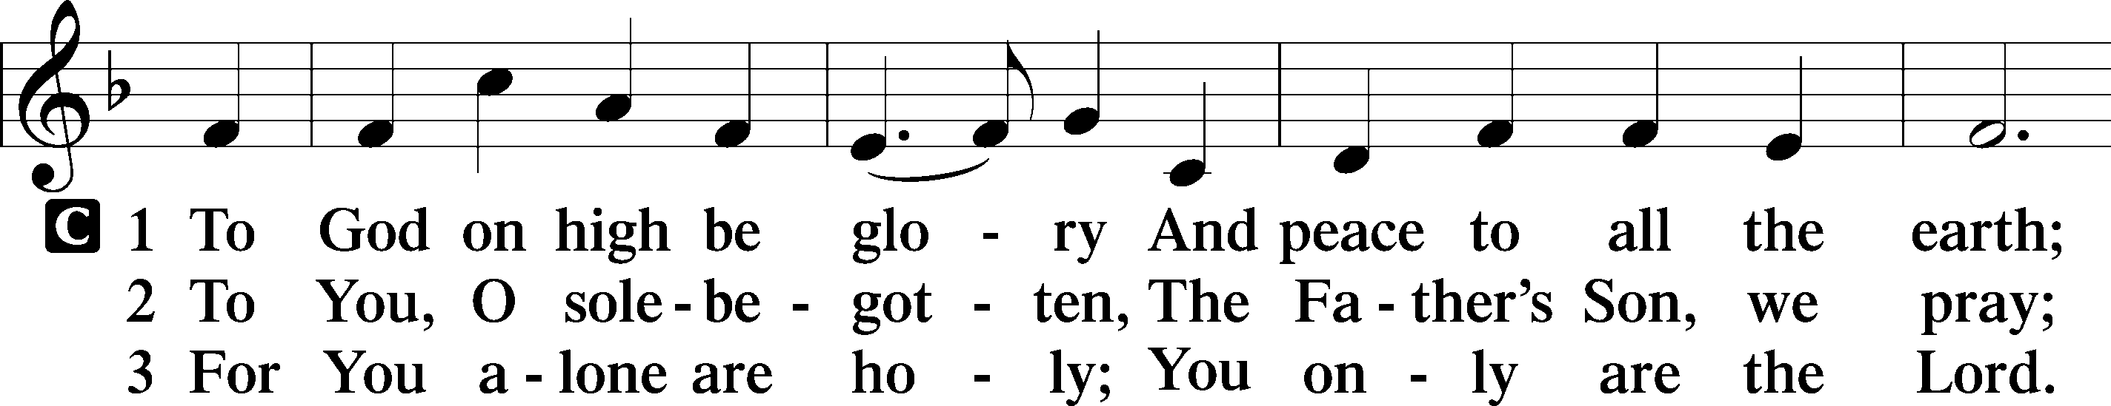
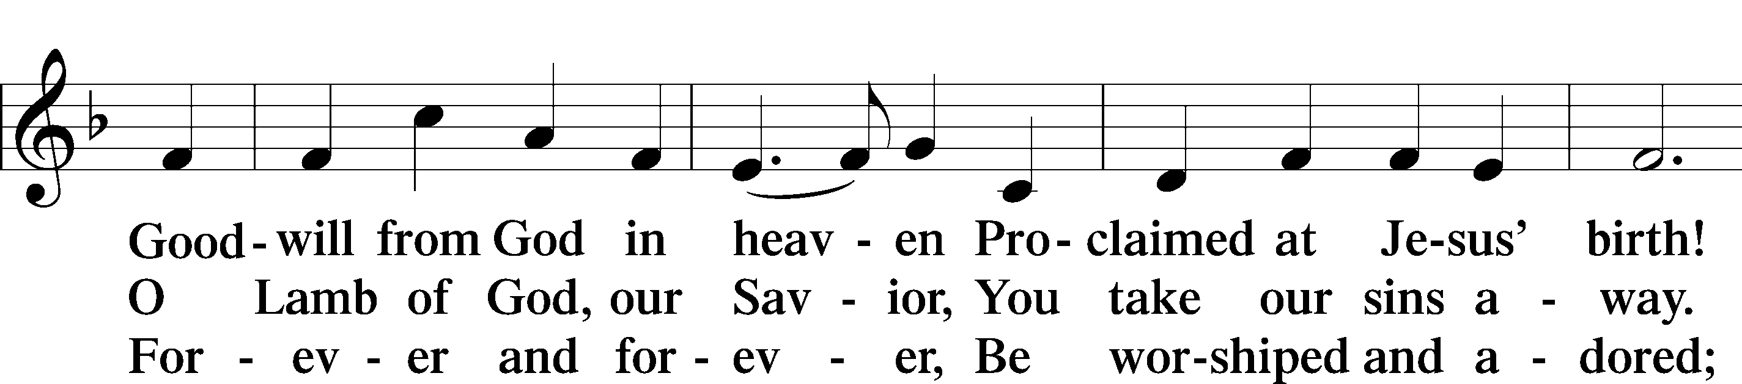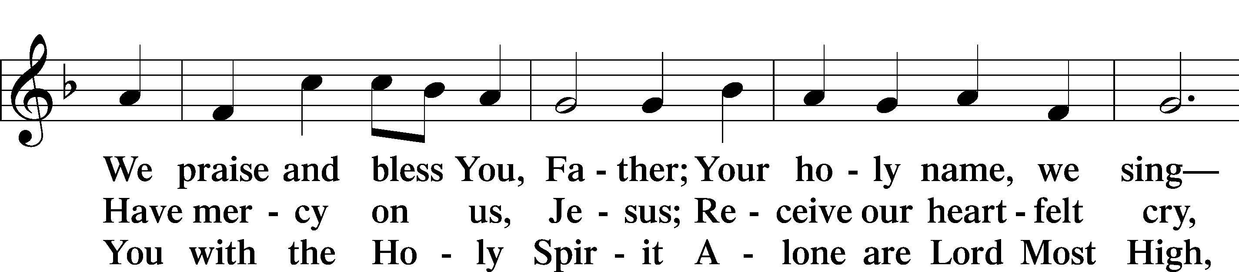
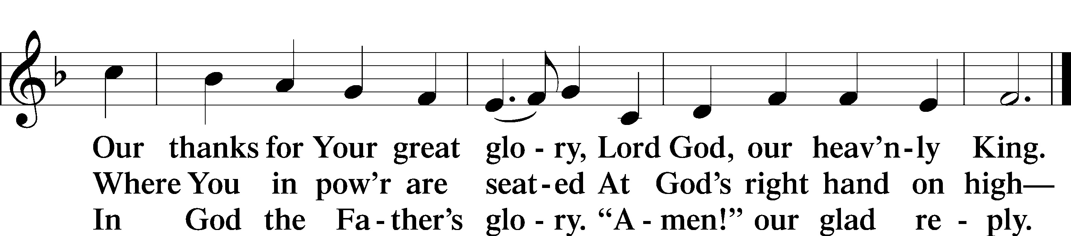
Text: Stephen P. Starke

SALUTATION AND COLLECT OF THE DAY
P The Lord be with you.
C And also with you.
P Let us pray.
O Lord, You have called us to enter Your kingdom through the narrow door. Guide us by Your Word and Spirit, and lead us now and always into the feast of Your Son, Jesus Christ, who lives and reigns with You and the Holy Spirit, one God, now and forever.
C Amen.

Please be seated

OLD TESTAMENT READING Isaiah 66:18–24
¹⁸“For I know their works and their thoughts, and the time is coming to gather all nations and tongues. And they shall come and shall see my glory, ¹⁹and I will set a sign among them. And from them I will send survivors to the nations, to Tarshish, Pul, and Lud, who draw the bow, to Tubal and Javan, to the coastlands afar off, that have not heard my fame or seen my glory. And they shall declare my glory among the nations. ²⁰And they shall bring all your brothers from all the nations as an offering to the Lord, on horses and in chariots and in litters and on mules and on dromedaries, to my holy mountain Jerusalem, says the Lord, just as the Israelites bring their grain offering in a clean vessel to the house of the Lord. ²¹And some of them also I will take for priests and for Levites, says the Lord.
²²“For as the new heavens and the new earth
that I make
shall remain before me, says the Lord,
so shall your offspring and your name remain.
²³From new moon to new moon,
and from Sabbath to Sabbath,
all flesh shall come to worship before me,
declares the Lord.
²⁴“And they shall go out and look on the dead bodies of the men who have rebelled against me. For their worm shall not die, their fire shall not be quenched, and they shall be an abhorrence to all flesh.”

P This is the Word of the Lord.
C Thanks be to God.

EPISTLE Hebrews 12:4–29
⁴In your struggle against sin you have not yet resisted to the point of shedding your blood. ⁵And have you forgotten the exhortation that addresses you as sons?
“My son, do not regard lightly the discipline of the Lord,
nor be weary when reproved by him.
⁶For the Lord disciplines the one he loves,
and chastises every son whom he receives.”
⁷It is for discipline that you have to endure. God is treating you as sons. For what son is there whom his father does not discipline? ⁸If you are left without discipline, in which all have participated, then you are illegitimate children and not sons. ⁹Besides this, we have had earthly fathers who disciplined us and we respected them. Shall we not much more be subject to the Father of spirits and live? ¹⁰For they disciplined us for a short time as it seemed best to them, but he disciplines us for our good, that we may share his holiness. ¹¹For the moment all discipline seems painful rather than pleasant, but later it yields the peaceful fruit of righteousness to those who have been trained by it.
¹²Therefore lift your drooping hands and strengthen your weak knees, ¹³and make straight paths for your feet, so that what is lame may not be put out of joint but rather be healed. ¹⁴Strive for peace with everyone, and for the holiness without which no one will see the Lord. ¹⁵See to it that no one fails to obtain the grace of God; that no “root of bitterness” springs up and causes trouble, and by it many become defiled; ¹⁶that no one is sexually immoral or unholy like Esau, who sold his birthright for a single meal. ¹⁷For you know that afterward, when he desired to inherit the blessing, he was rejected, for he found no chance to repent, though he sought it with tears.
¹⁸For you have not come to what may be touched, a blazing fire and darkness and gloom and a tempest ¹⁹and the sound of a trumpet and a voice whose words made the hearers beg that no further messages be spoken to them. ²⁰For they could not endure the order that was given, “If even a beast touches the mountain, it shall be stoned.” ²¹Indeed, so terrifying was the sight that Moses said, “I tremble with fear.” ²²But you have come to Mount Zion and to the city of the living God, the heavenly Jerusalem, and to innumerable angels in festal gathering, ²³and to the assembly of the firstborn who are enrolled in heaven, and to God, the judge of all, and to the spirits of the righteous made perfect,²⁴and to Jesus, the mediator of a new covenant, and to the sprinkled blood that speaks a better word than the blood of Abel.
²⁵See that you do not refuse him who is speaking. For if they did not escape when they refused him who warned them on earth, much less will we escape if we reject him who warns from heaven. ²⁶At that time his voice shook the earth, but now he has promised, “Yet once more I will shake not only the earth but also the heavens.” ²⁷This phrase, “Yet once more,” indicates the removal of things that are shaken—that is, things that have been made—in order that the things that cannot be shaken may remain. ²⁸Therefore let us be grateful for receiving a kingdom that cannot be shaken, and thus let us offer to God acceptable worship, with reverence and awe, ²⁹for our God is a consuming fire.

P This is the Word of the Lord.
C Thanks be to God.

Please stand as able

ALLELUIA AND VERSE
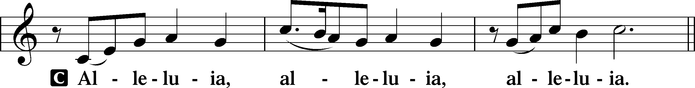
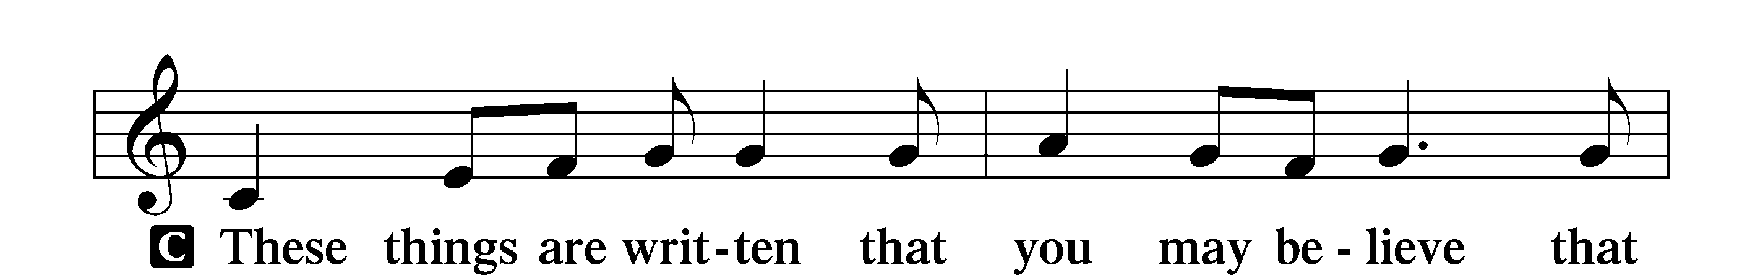
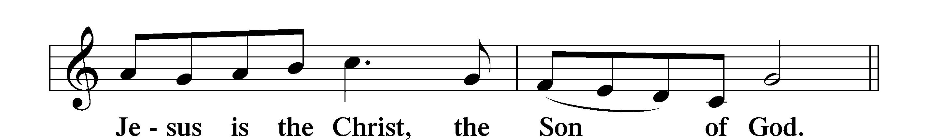
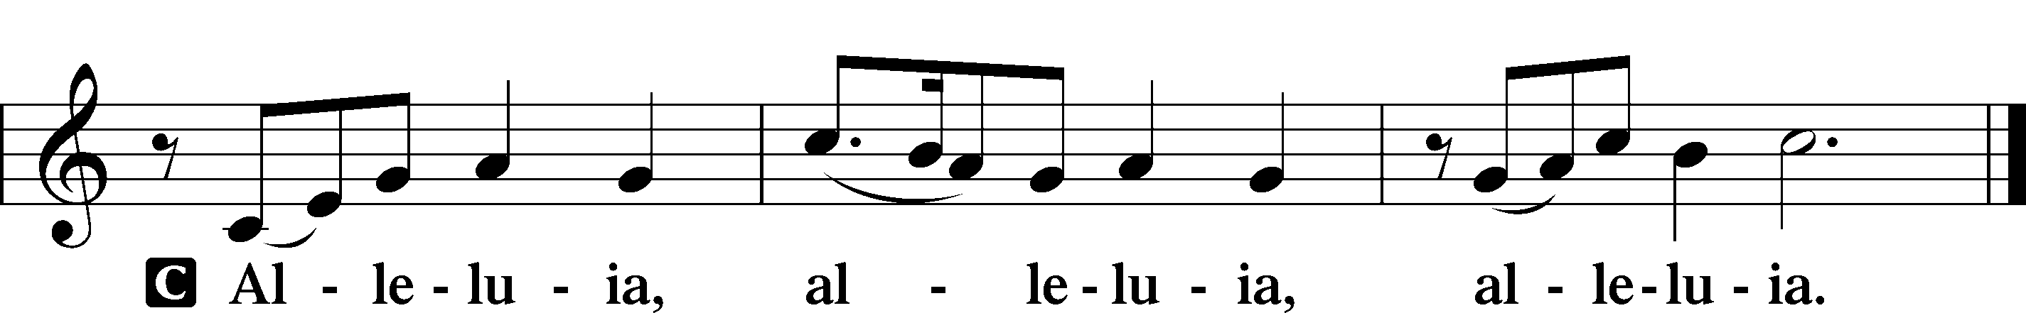

HOLY GOSPEL Luke 13:22–30
P The Holy Gospel according to St. Luke, the thirteenth chapter.
C Glory to You, O Lord.
²²[Jesus] went on his way through towns and villages, teaching and journeying toward Jerusalem. ²³And someone said to him, “Lord, will those who are saved be few?” And he said to them, ²⁴“Strive to enter through the narrow door. For many, I tell you, will seek to enter and will not be able. ²⁵When once the master of the house has risen and shut the door, and you begin to stand outside and to knock at the door, saying, ‘Lord, open to us,’ then he will answer you, ‘I do not know where you come from.’ ²⁶Then you will begin to say, ‘We ate and drank in your presence, and you taught in our streets.’ ²⁷But he will say, ‘I tell you, I do not know where you come from. Depart from me, all you workers of evil!’ ²⁸In that place there will be weeping and gnashing of teeth, when you see Abraham and Isaac and Jacob and all the prophets in the kingdom of God but you yourselves cast out. ²⁹And people will come from east and west, and from north and south, and recline at table in the kingdom of God. ³⁰And behold, some are last who will be first, and some are first who will be last.”
P This is the Gospel of the Lord.
C Praise to You, O Christ.

NICENE CREED
C I believe in one God,
the Father Almighty,
maker of heaven and earth
and of all things visible and invisible.
And in one Lord Jesus Christ,
the only-begotten Son of God,
begotten of His Father before all worlds,
God of God, Light of Light,
very God of very God,
begotten, not made,
being of one substance with the Father,
by whom all things were made;
who for us men and for our salvation came down from heaven
and was incarnate by the Holy Spirit of the virgin Mary
and was made man;
and was crucified also for us under Pontius Pilate.
He suffered and was buried.
And the third day He rose again according to the Scriptures
and ascended into heaven
and sits at the right hand of the Father.
And He will come again with glory to judge both the living and the dead,
whose kingdom will have no end.
And I believe in the Holy Spirit,
the Lord and giver of life,
who proceeds from the Father and the Son,
who with the Father and the Son together is worshiped and glorified,
who spoke by the prophets.
And I believe in one holy Christian and apostolic Church,
I acknowledge one Baptism for the remission of sins,
and I look for the resurrection of the dead
and the life T of the world to come. Amen.

Please be seated

ALL GOD’S CHILDREN – TALK

SERMON HYMN
Today Your Mercy Calls Us LSB 915
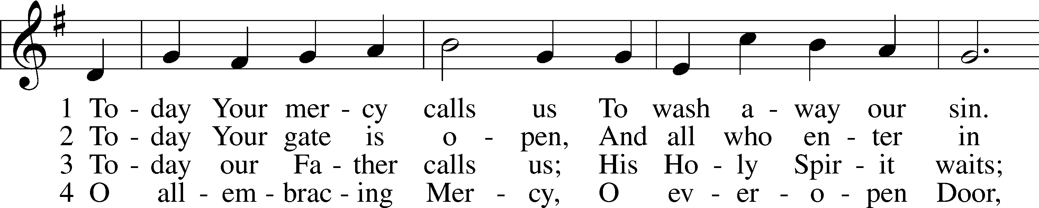
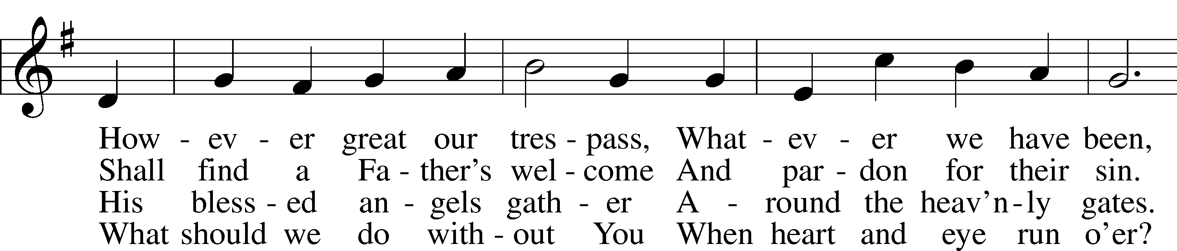
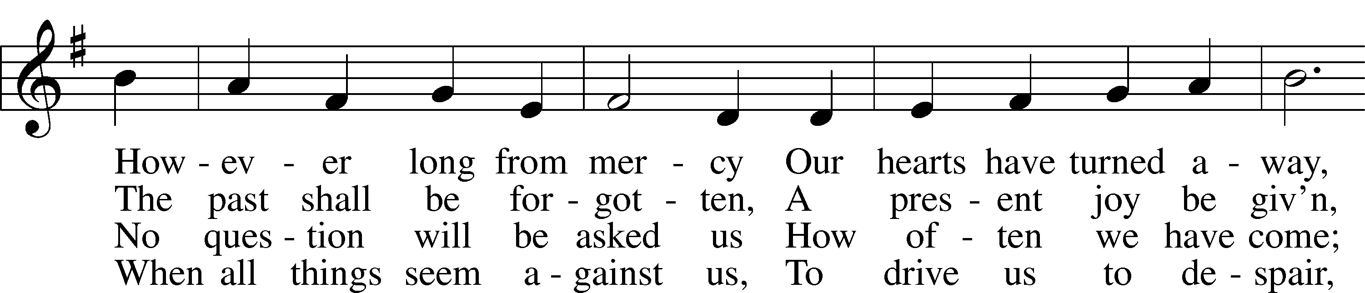
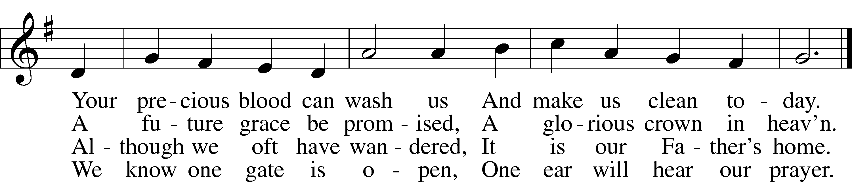
Text: Oswald Allen, 1816–78, alt.
Tune: Friedrich K. Anthes, 1812–after 1857
Text and tune: Public domain

SERMON

Please stand as able

PRAYER of the CHURCH
After each Segment:
P Lord, in Your Mercy,
C Hear our Prayer.
After Final Segment:
P Hear us as we pray in His name and as He has taught us:
LORD’S PRAYER
C Our Father who art in heaven,
hallowed be Thy name,
Thy kingdom come,
Thy will be done on earth
as it is in heaven;
give us this day our daily bread;
and forgive us our trespasses
as we forgive those
who trespass against us;
and lead us not into temptation,
but deliver us from evil.
For Thine is the kingdom
and the power and the glory
forever and ever. Amen.

T SERVICE of the SACRAMENT T

PREFACE LSB 208
P The Lord be with you.
C And also with you.
P Lift up your hearts.
C We lift them to the Lord.
P Let us give thanks to the Lord our God.
C It is right to give Him thanks and praise.
P It is truly good, right, and salutary that we should at all times and in all places give thanks to You, O Lord, holy Father, almighty and everlasting God, for the countless blessings You so freely bestow on us and all creation. Above all, we give thanks for Your boundless love shown to us when You sent Your only-begotten Son, Jesus Christ, into our flesh and laid on Him our sin, giving Him into death that we might not die eternally. Because He is now risen from the dead and lives and reigns to all eternity, all who believe in Him will overcome sin and death and will rise again to new life. Therefore with angels and archangels and with all the company of heaven we laud and magnify Your glorious name, evermore praising You and singing:

SANCTUS LSB 208
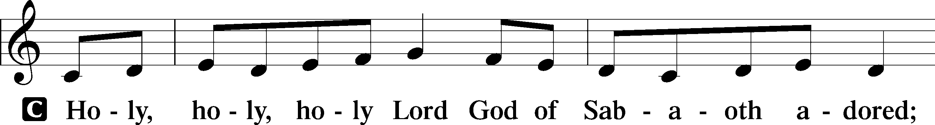
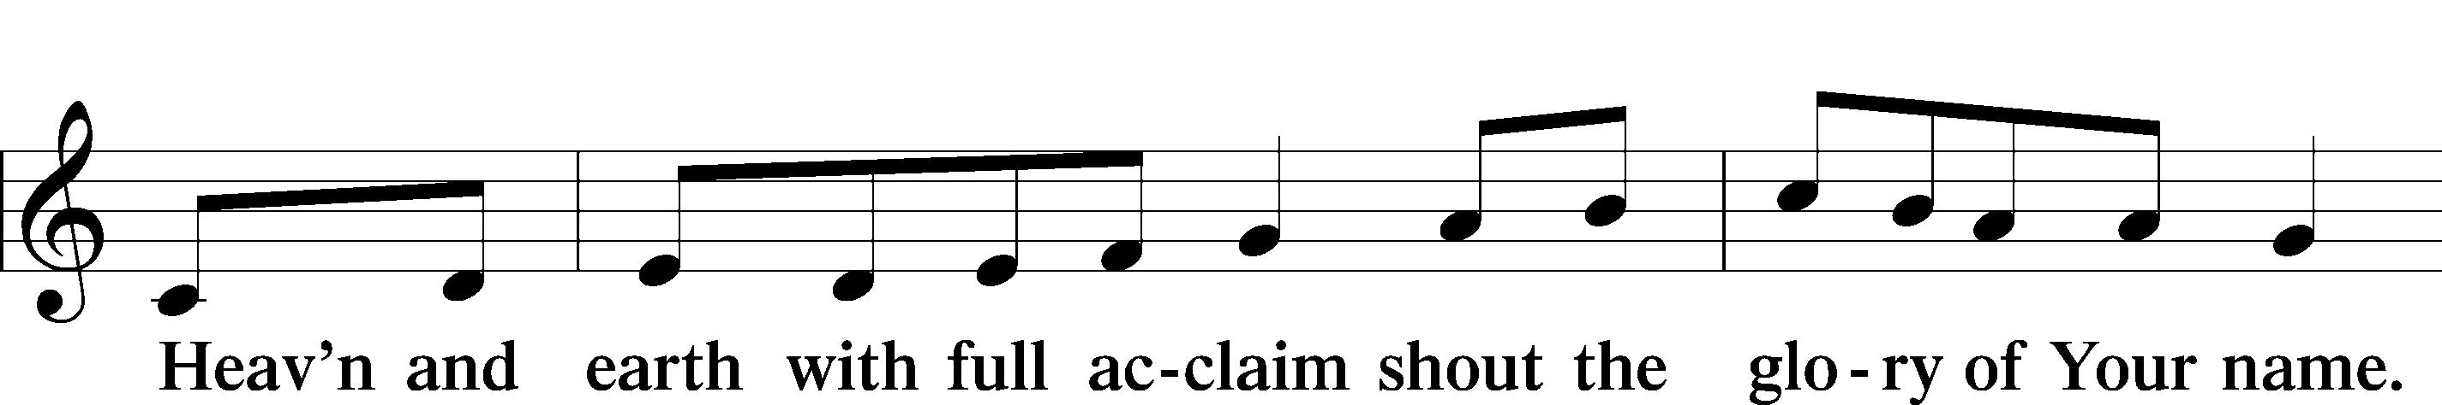
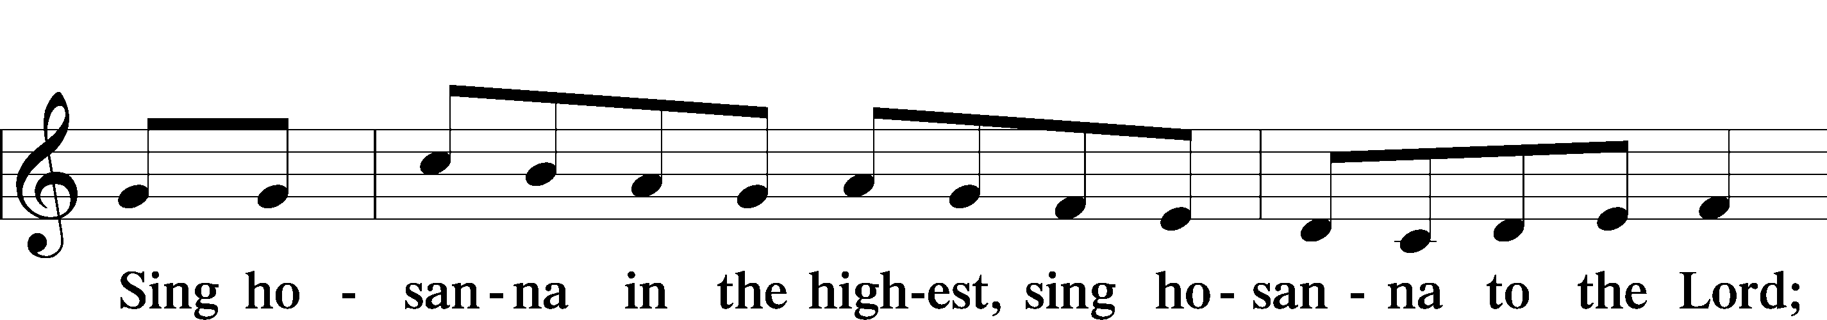
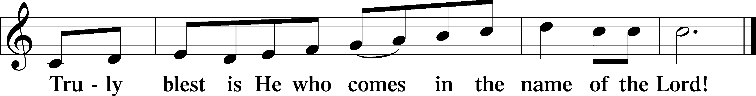

THE WORDS OF OUR LORD
P Our Lord Jesus Christ, on the night when He was betrayed, took bread, and when He had given thanks, He broke it and gave it to the disciples and said: “Take, eat; this is My T body, which is given for you. This do in remembrance of Me.”
In the same way also, He took the cup after supper, and when He had given thanks, He gave it to them, saying: “Drink of it, all of you; this cup is the New Testament in My T blood, which is shed for you for the forgiveness of sins. This do, as often as you drink it, in remembrance of Me.”

PAX DOMINI
P The peace of the Lord be with you always.
C Amen.

AGNUS DEI
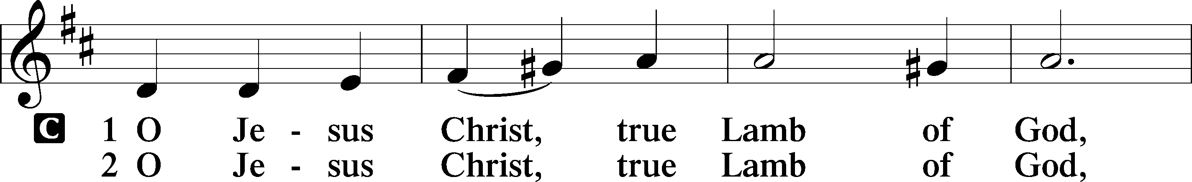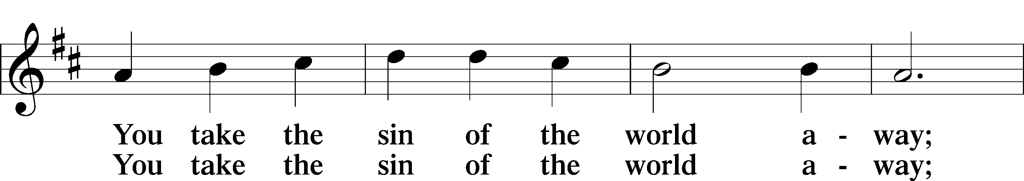
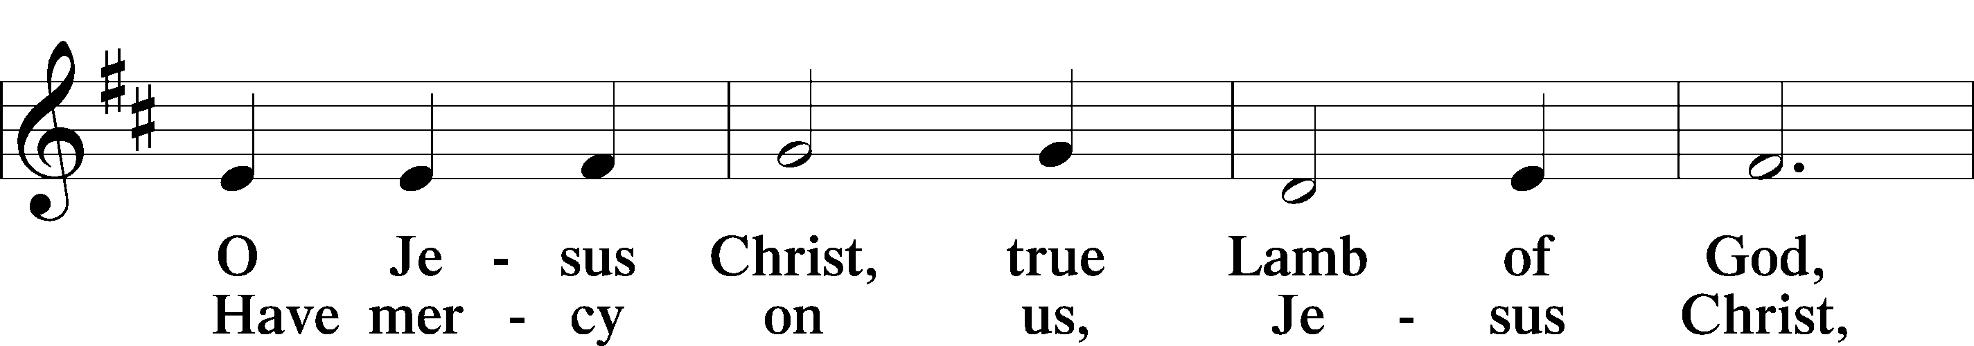
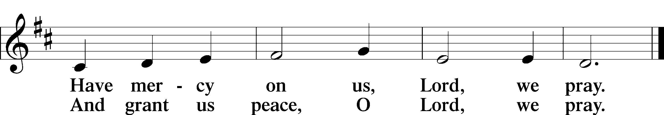

Please be seated
DISTRIBUTION
The pastor and those who assist him receive the body and blood of Christ first, then Communion will be served at the rail. Ushers will help direct you forward via the center aisle; please return to your seats via the side aisles. Gluten-free bread is available for those who need it, as is non-alcoholic grape juice. Simply request either when you come forward to receive Communion.

DISTRIBUTION HYMN
My Hope Is Built on Nothing Less LSB 575
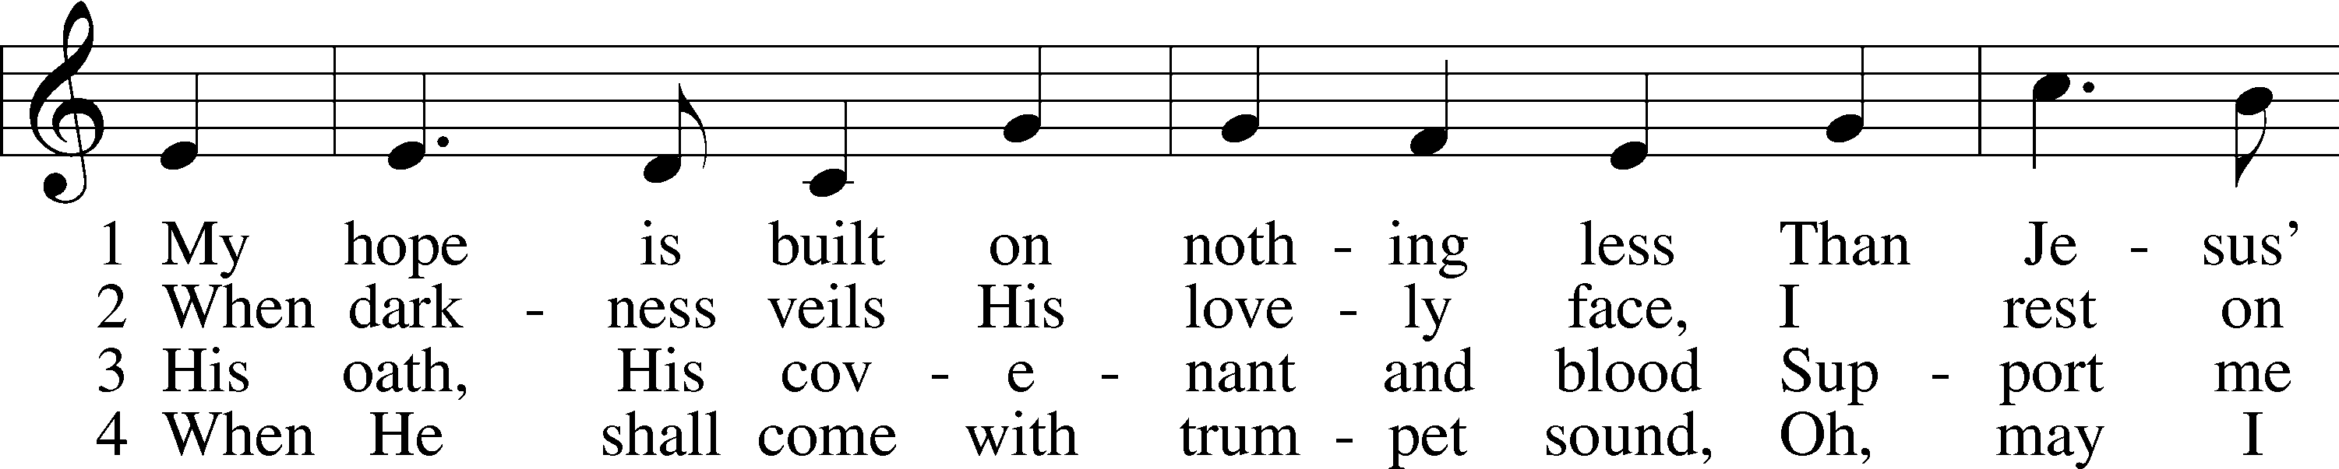
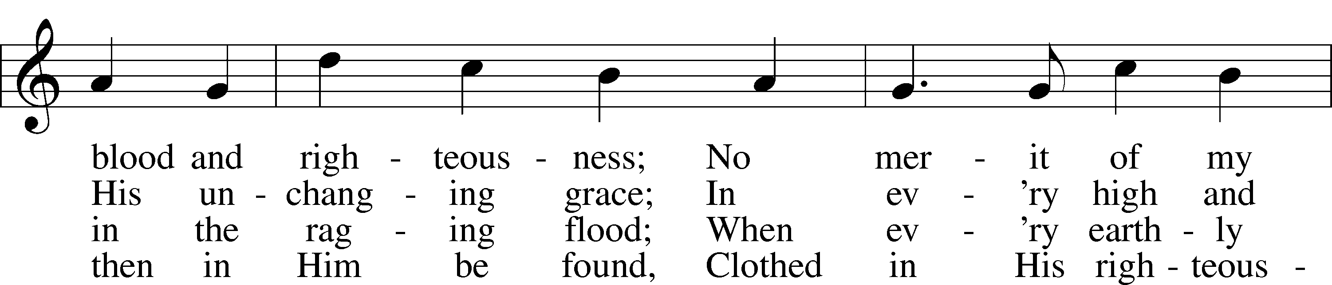
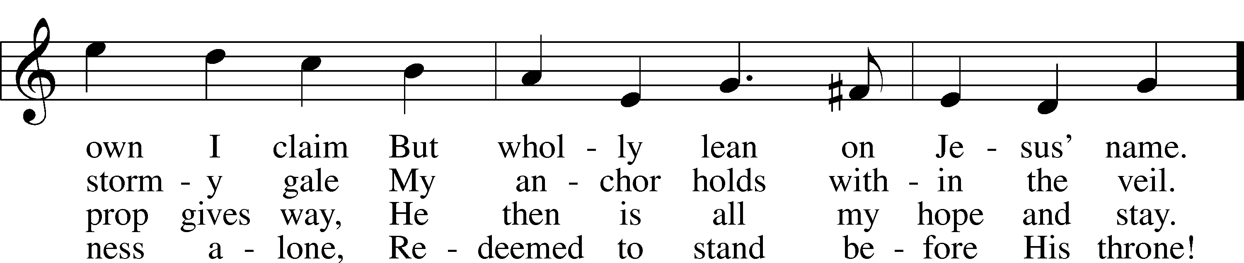
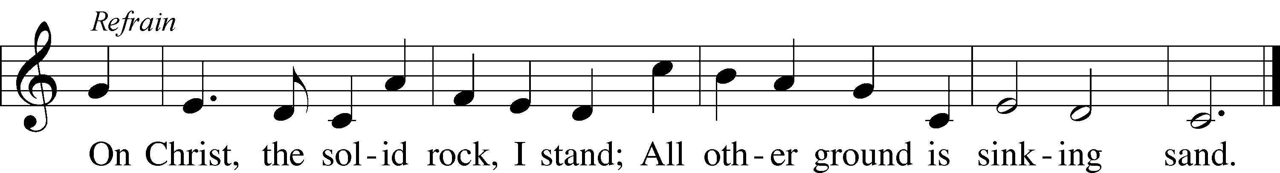
Text: Edward Mote, 1797–1874, alt.
Tune: John Stainer, 1840–1901
Text and tune: Public domain
Please stand as able

NUNC DIMITTIS LSB 211
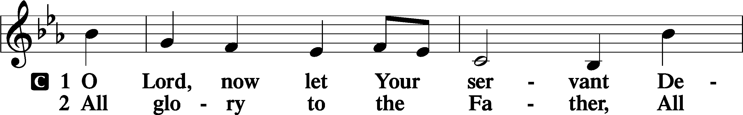
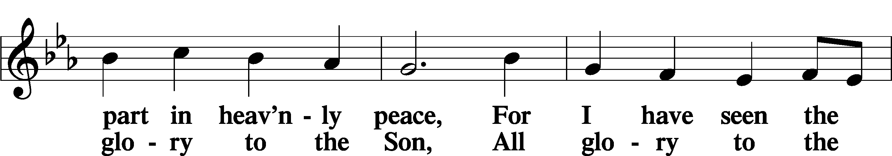
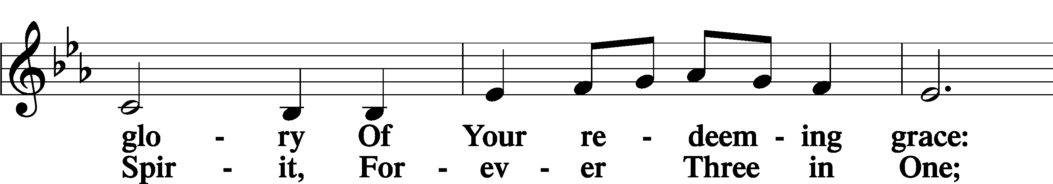
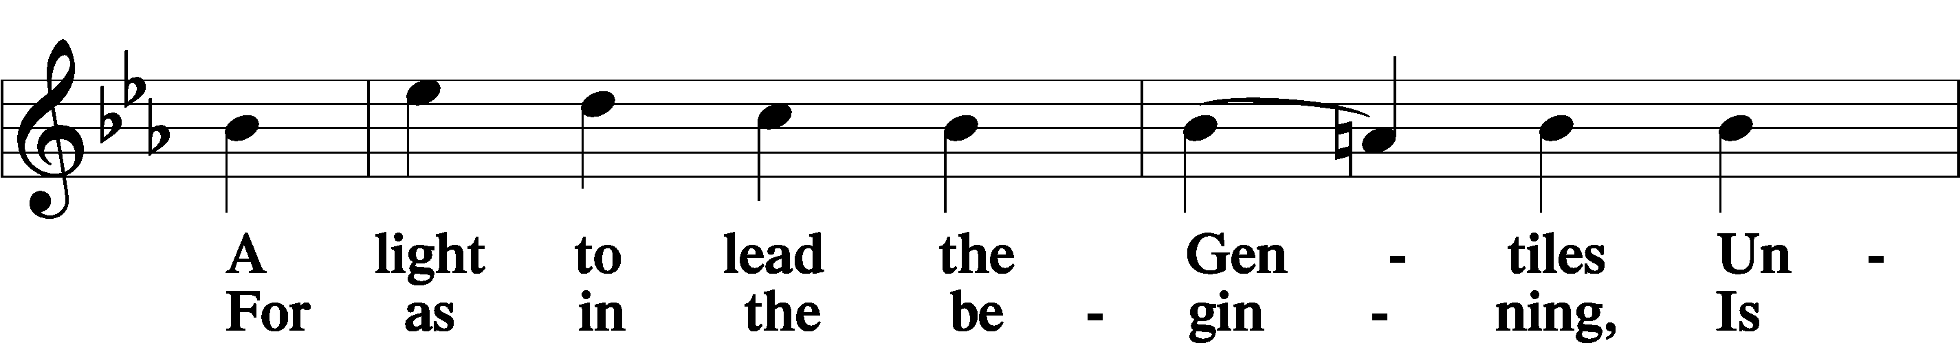
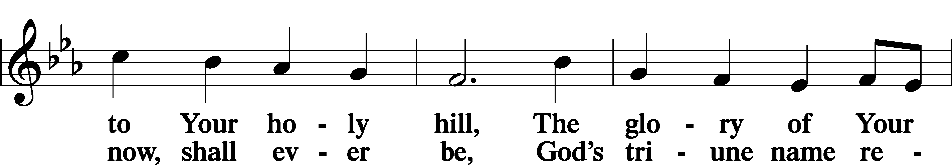
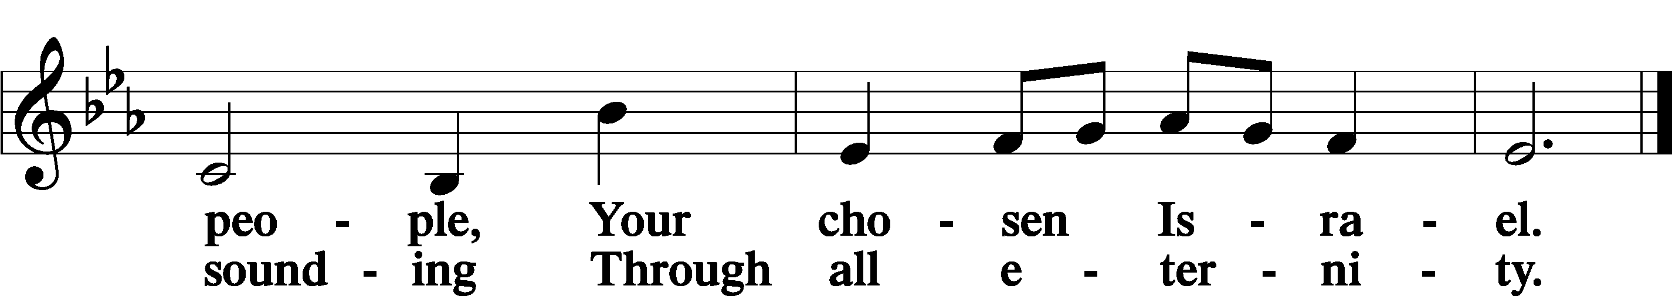

POST COMMUNION COLLECT
P Let us pray.
O God the Father, the fountain and source of all goodness, who in loving-kindness sent Your only-begotten Son into the flesh, we thank You that for His sake You have given us pardon and peace in this Sacrament, and we ask You not to forsake Your children but always to rule our hearts and minds by Your Holy Spirit that we may be enabled constantly to serve You; through Jesus Christ, Your Son, our Lord, who lives and reigns with You and the Holy Spirit, one God, now and forever.
C Amen.

BENEDICAMUS LSB 212
P Let us bless the Lord.
C Thanks be to God.
BENEDICTION
P The Lord bless you and keep you.
The Lord make His face shine on you and be gracious to you.
The Lord look upon you with favor and T give you peace.
C Amen.
Please be seated
CLOSING HYMN
Rejoice, O Pilgrim Throng LSB 813 sts. ref, 4–7 Please Stand on V.7
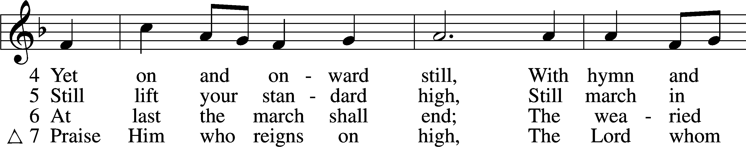
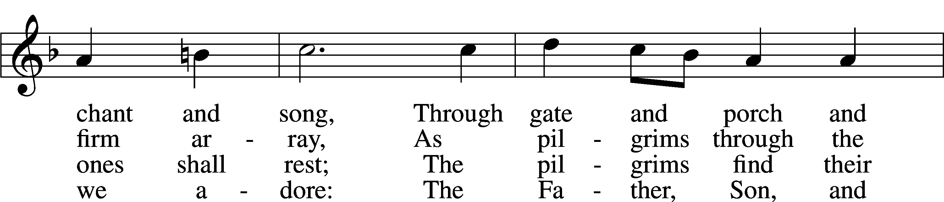
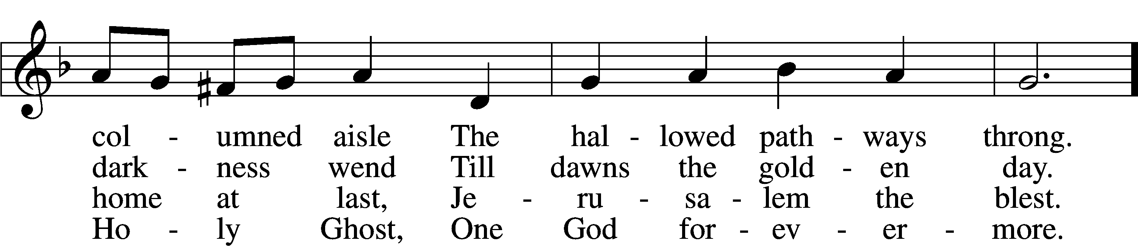
Text: Edward H. Plumptre, 1821–91, alt.
Tune: Arthur H. Messiter, 1834–1916
Text and tune: Public domain

ANNOUNCEMENTS and SENDING WORDS
P We go to live for Jesus!
C We go to share His love!

Acknowledgments Unless otherwise indicated, Scripture quotations are from the ESV® Bible (The Holy Bible, English Standard Version®), copyright © 2001 by Crossway, a publishing ministry of Good News Publishers. Used by permission. All rights reserved.
Created by Lutheran Service Builde

SERVING IN GOD’S HOUSE TODAY
Pastor: Rev. Paul Schneider
Elder: Tom Raithel
Ushers: Mike Goodrich, Risa Sherman
Greeters: Bob & Kathy Erat
Counters: Ric Francis, Kathy Erat
Coffee Servers: Kunisch
Altar Care: Ann Mertz
Virtual Organist: Terri Raithel
Children’s Talk Pastor Paul Schneider
Post-Service Bible Study to resume in September.

PRAYERS
Please contact the office with updates to the prayer list. People will remain on the prayer list for 4 weeks before being removed. If they need to remain on the list, please keep Elaine informed and of any updates. This will help us to have a more accurate list. Thanks for your cooperation.
Those who continue to grieve the passing of loved ones, The Family of Dolores Mouch.
Those with upcoming surgery: Joann Whitney (August 23rd)
Those recovering from surgery:
Those with health concerns: Tiffany Amsdill, Hope Buchinger,
Betsy Cook, Kay Gregg, Paul Kietzman, Hilda Koch, Jennifer Martin, Ron Kwapis, Eleanor Raether, Beth Smith, AND Judi Stutzman.
Those diagnosed with cancer: Leah Eicher, Rachel Frisch, Janice Knoellinger, Leslie Martin, Brian Morgan, Hope Osantowski, and John Stutzman.
Those under Hospice Home Care: Ken Williamson, Jim (Joann Whitney’s brother-in law).

BIRTHDAYS: ANNIVERSARIES;
8/23 Larry Whitney 8/21 Bill & Terry Stiles
8/26 Rich Wagner 8/23 Steve & Judy Anderson

MESSAGES

ALTAR FLOWERS today are given to the glory of God by John & Judi Stutzman.
MEMBER & GUEST CARDS: If you have not filled out a member/guest card, please take the time to fill one out and place it in the plate behind the back pews in our sanctuary.
GREETING CARDS If you are in need of some greeting cards, we carry an array of them. The card cabinet is in the hallway across from the library. The cost of the cards is posted on the cabinet. The money collected from the cards goes to LWML to help support Missions.
CANCER and FRIENDS SUPPORT GROUP: Will be meeting in August 23rd. Our guest speaker will be Shannon from Yoga 45. Please remember Cancer & Friends Support Group is not just for people going through treatment, or survivors, we are also here for caregiver, spouse, children, and friends. There are times when we can all use someone to talk to during those difficult times. If there is any subject you would like to discuss with me you call or text or at 989-350-4391. Hope you will join us.
CHURCH EXTENSION FUND has proven investment products with measurable results. Since 1901, through dedicated Christian financial management, CEF is focused on funding the needs of Michigan District congregations. (Proven, Dedicated, Focused)
For more information, contact (Congregation Representative and telephone number) or call 800-242-3944.
WEDNESDAY MORNING BIBLE STUDY will resume in September
LARGE PRINT WORSHIP FOLDERS: We now have large print worship folders they are on the table in the back of the church with the offerings. Please fill free to take on

THIS WEEK AT TRINITY

August 21 Sunday
9:00 am Worship Service
10:00 am Fellowship & Coffee Hour
August 22 Monday
August 23 Tuesday
5:30 pm Cancer & Friends Support Group
Shannon from yoga 45 will be our guest speaker.
August 24 Wednesday
August 25 Thursday
11:15am Special Elders Meeting
August 26 Friday
August 27 Saturday
August 28 Sunday
9:00 am Worship Service
Noisy Offering
10:00 am Fellowship & Coffee Hour

SERVING IN GOD’S HOUSE NEXT SUNDAY 8/28/2022
Pastor: Rev. Ken Bernthal
Elder: Ken Mertz
Ushers: Tom Raithel, Linda West
Greeters: Appold Family
Counters: Larry Whitney, Wendell Smith
Coffee Servers: Paul & Karen Schneider
Altar Care: Nancy Ely
Piano/ Organ: Tom & Jean Beach
Children’s Talk: Nancy Ely
Post-Service Bible Study to resume in September.

